A Major Project Proposal Report on

**Smart Pharma Demand Forecasting**

Submitted in Partial Fulfillment of the Requirements for

the Degree of Bachelor of Engineering in **Software Engineering**

under Pokhara University

Submitted by:

**Prabin Kumar Shah, 181728**

**Bishwajyoti Chaudhary, 181709**

**Deepak Yadav, 181711**

**Deekshya Maharjan, 181710**

Under the supervision of

**Dr. Roshan Chitrakar**

Date:

11/05/2023

|  |  |
| --- | --- |
|  | **Department of Software Engineering**  NEPAL COLLEGE OF INFORMATION TECHNOLOGY  Balkumari, Lalitpur, Nepal |

**Abstract**

Smart Pharma Demand Forecasting is a web application designed to streamline the supply chain in the pharmaceutical industry. This application facilitates collaboration between pharmaceutical companies, stockists, and local pharmacies, enabling local pharmacies to conveniently order medicines directly from stockists. By eliminating the traditional process of phone calls and paper-based order notes, the application significantly improves efficiency and accuracy. Additionally, the application provides demand forecasting capabilities for pharmaceutical companies.

The web app is developed specifically to address the challenges faced by retail pharmacies in the ordering process. Through user-friendly interface, local pharmacies can browse the available medicines, select the required items, and place orders directly with stockists. This eliminates the time-consuming and error-prone nature of manual order placement, resulting in improved operational efficiency.

Moreover, the application empowers pharmaceutical companies with the ability to forecast demand accurately. By leveraging historical sales data, prescription patterns, and other relevant factors, the application employs advanced algorithms to generate reliable demand forecasts. This enables pharmaceutical companies to optimize their production schedules, inventory levels, and distribution strategies, ultimately improving overall supply chain management.

As a web application, Smart Pharma Demand Forecasting ensures accessibility and flexibility. It can be accessed from any device with an internet connection, allowing users to place orders and access demand forecasts conveniently. The web app is developed using modern web technologies, ensuring a seamless and secure user experience.

In conclusion, Smart Pharma Demand Forecasting is a web application that revolutionizes the ordering process in the pharmaceutical industry. By enabling local pharmacies to order medicines directly from stockists and providing accurate demand forecasts for pharmaceutical companies, the application enhances efficiency, reduces errors, and improves supply chain management. The web-based nature of the application ensures accessibility and scalability, making it a valuable tool for all stakeholders involved.

**Contents**

1. Problem statement 1

2. Project Objectives 1

3. Significance of the study 2

4. Scope and Limitation 2

4.1 Scope: 2

4.2 Limitation: 2

5. Literature Study/Review 3

6. Proposed Methodology/ Technical description of the Project 3

6.1 Model Development: 3

6.2 Process model: 4

6.2.1 Analysis Phase: 4

6.2.2 Design Phase: 4

6.2.3 Coding Phase: 4

6.2.4 Testing Phase: 5

6.3 System Design 5

6.4 Programming Language and Other Tools 6

6.4.1 Programming Language 6

6.4.2 Database 6

6.4.3 Framework to Be Used 6

6.4.4 Tools to Be Used 7

7. Proposed Performance Analysis Methodology and Validation Scheme 7

8. Proposed Deliverable/Output 8

9. Project task and Time schedule 8

9.1 Project Task 8

9.2 Time Schedule 9

Bibliography/References 10

Top of Form

Bottom of Form

**List of Figures**

Figure 1: Model Development 3

Figure 2: Incremental Order 4

Figure 3: Use Case Diagram 5

Figure 4: Project Task 9

# List of Tables

Table 1: Programming languages 6

Table 2: Framework 6

Table 3: Tools 7

Table 4: Time Schedule 9

# Problem statement

The traditional process of retail pharmacies ordering drugs through phone calls and suppliers manually recording orders on paper has resulted in increased chances of errors and a time-consuming process. This poses a significant problem in the pharmaceutical industry as companies struggle to deliver the correct quantity of products to suppliers in a timely manner. The primary reason behind this problem is the failure of companies to identify rapid changes in demand quantity and remain unaware of competitor demand within the supply chain management process. This lack of real-time information and forecasting capabilities hampers effective supply chain management and leads to inefficiencies in inventory management and distribution. Therefore, there is a critical need for improved order management systems and accurate demand forecasting methods to address these challenges and enhance the overall performance of the pharmaceutical industry supply chain.

# Project Objectives

To address the drawbacks mentioned in problem statement section, the project aims to evolve by achieving the following objectives:

1. To create a user-friendly web application that enables retail pharmacies to place drug orders directly with suppliers, eliminating the reliance on phone calls and paper-based order notes.

2. To implement advanced data analysis techniques and machine learning algorithms to achieve accurate demand forecasting, with the aim of minimizing overproduction.

3. To enable suppliers to monitor and manage inventory levels based on the demand forecasts received from pharmaceutical companies.

# Significance of the study

The Smart Pharma Demand Forecasting project is significant for the pharmaceutical industry as it can address several challenges faced by the industry, improve efficiency and convenience for customers, and enhance the overall profitability and competitiveness of pharmaceutical companies. The study is also significant as it provides an opportunity to explore the benefits and drawbacks of similar systems in use and contribute to the development of innovative solutions in the pharmaceutical industry.

# Scope and Limitation

## 4.1 Scope:

The Smart Pharma Demand Forecasting project aims to develop a web-based application to optimize demand forecasting and supply chain management by facilitating efficient collaboration among pharmaceutical companies, stockists, and local pharmacies in the pharmaceutical industry. The scope of the project includes the following:

1. The proposed system serves as a platform for pharmaceutical companies, stockists, and local pharmacies, enabling seamless medicine ordering for local pharmacies and accurate demand forecasting for pharmaceutical companies.  
2. By incorporating essential enhancements, the proposed system can extend its functionality to include an e-commerce platform for pharmacies, enabling end-users to conveniently order medicines by uploading their prescriptions.

## Limitation:

1.The accuracy and effectiveness of the demand forecasting heavily rely on the availability of relevant and up-to-date data. Limited or incomplete data can lead to less accurate predictions and hinder the overall performance of the system.

2. As a web-based application, the proposed system requires a stable internet connection to perform any operation. Disruptions or unavailability of internet connectivity may impact the system's functionality and restrict users' ability to place orders or access critical information.

# Literature Study/Review

1. NepMeds:

In context of Nepal, NepMeds app provides a variety of health-related services such as connecting users with doctors, booking diagnostic tests, and ordering medicines and wellness products. The app also offers a wide range of categories for different types of medicines and healthcare products.

However, it seems that the app does not have the feature of demand forecasting, which is essential for pharmaceutical companies to optimize their inventory levels and improve supply chain management. Additionally, retail pharmacies are unable to order medicines in bulk, which may limit their ability to save costs and improve their efficiency.

Therefore, there is still a need for a Pharmacy Management System with Demand Forecasting in Nepal that can address these limitations and provide pharmaceutical companies and retail pharmacies with the necessary tools to improve their operations. So, we have come up with this idea to resolve the limitation of existing system.

# Proposed Methodology/ Technical description of the Project

## 6.1 Model Development:

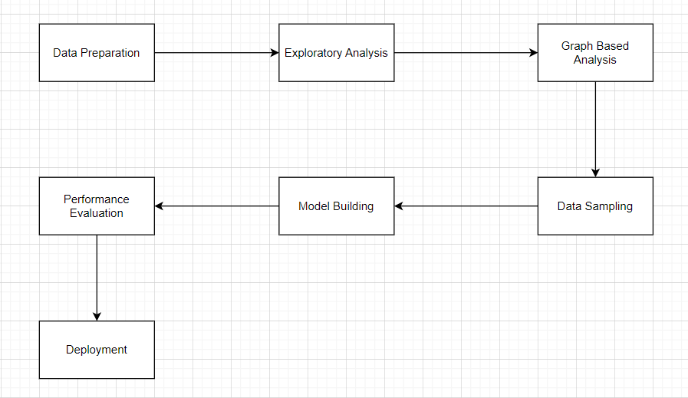

Figure 1: Model Development

6.2 Process model:

The framework we followed in developing this project is incremental model, which is a use of linear sequential model in an iterative manner. New functionalities will be added as each increment was developed. Linear sequential model will be applied to develop each increment. The phases of the linear sequential model are: Analysis, Design, Coding and Testing. The software repeatedly passes through these phases in iteration and an increment is delivered with progressive changes.

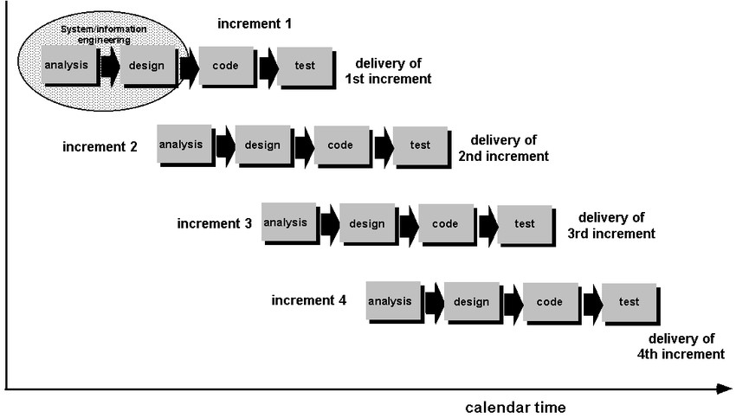

Figure 2: Incremental Order

6.2.1 Analysis Phase:

In this phase, analysis will be done in order to find out the requirements of the system. The outcome of this phase is an SRS which is an acronym for “System Requirement Specifications”.

6.2.2 Design Phase:

In this phase the SRS will be translated into the system’s design. Context Diagram, DFD, ER-Diagram, Use Case Diagram and Class Diagram will be developed.

6.2.3 Coding Phase:

In this phase coding will done according to the design and a working system will be developed by the end of this process.

6.2.4 Testing Phase:

In this phase, the system will be tested. With each testing a list of changes to the system will be developed, suggested and the changes will be applied to the software and the software will be delivered as a successive increment until a satisfying system will be achieved.

## 6.3 System Design

A use case diagram at its simplest is a representation of a user's interaction with the system that shows the relationship between the user and the different use cases in which the user is involved. The actors for our system are: User, Admin, Company, Pharmacy, Supplier, Pharmacist, Delivery boy. The simplified and graphical representation of what our system must actually do is represented below:

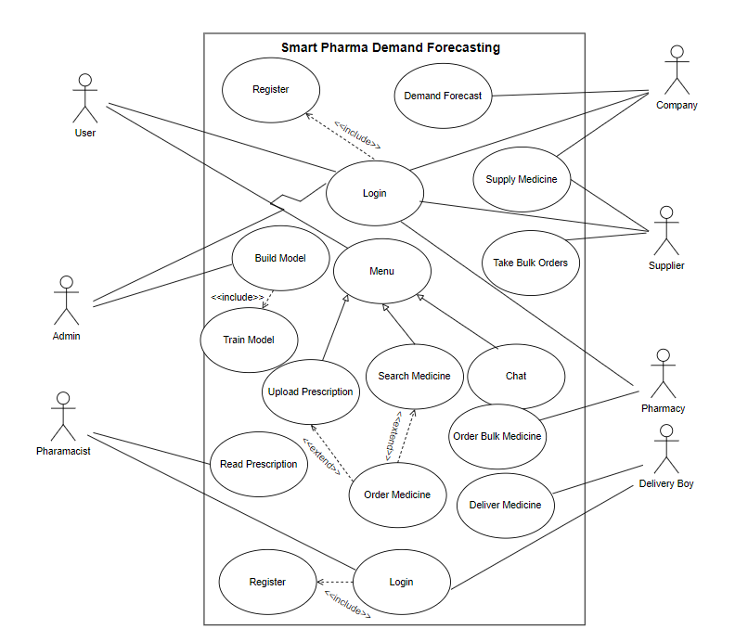

Figure 3: Use Case Diagram

## 6.4 Programming Language and Other Tools

### 6.4.1 Programming Language

We have decided to use Java and Python as the programming language for the development of Smart Pharma Demand Prediction.

|  |  |
| --- | --- |
| Programming Language | Application |
| Frontend | HTML, CSS, JavaScript |
| Backend | Java, Python |

Table 1: Programming languages

### 6.4.2 Database

MySQL is an open-source relational database management system that uses SQL (Structured Query Language) to manage and manipulate data stored in a database.

### 6.4.3 Framework to Be Used

Below are the major framework we have decided to use in the development of our project

|  |  |
| --- | --- |
| Framework | Application |
| Spring | Spring Framework is an open-source, lightweight, modular framework for building enterprise-grade Java applications. |
| Bootstrap | Bootstrap is a free and open-source front-end framework for building responsive web applications. |
| TesnsorFlow | TensorFlow is an open-source machine learning platform developed by Google. |

Table 2: Framework

### 6.4.4 Tools to Be Used

Tools used in design, development and testing of software are mentioned in the table below:

|  |  |
| --- | --- |
| Tools | Application |
| IDE (Eclipse, Visual Studio) | To write code. |
| Git and GitHub | To manage the project’s source code and versions locally and remotely respectively. |
| EdrawMax | To design components. |
| MySQL Workbench | To manage databases. |

Table 3: Tools

# Proposed Performance Analysis Methodology and Validation Scheme

To evaluate the performance of the Smart Pharma with Demand Forecasting, the following methodology and validation scheme are proposed:

1. Usability Testing: Conduct usability testing with potential users to assess the user interface's ease of use and navigation.
2. Functionality Testing: Perform testing on the system to ensure that all features work as expected, such as ordering, prescription upload, and demand forecasting.
3. Load Testing: Conduct load testing to ensure that the system can handle a large number of concurrent users and orders without performance degradation.
4. Security Testing: Perform security testing to ensure that the system is secure against common security threats, such as SQL injection attacks and cross-site scripting.
5. Validation Scheme: Validate the system's performance by comparing the results with the system's objectives. Compare the actual system performance with the expected performance metrics, such as order fulfillment time, accuracy of demand forecasting, and user satisfaction.

# Proposed Deliverable/Output

The project is delivered in the form of web application. The final project has following features:

1. A web application with a user-friendly interface.
2. Registration and login functionality for users, pharmaceutical companies, suppliers, pharmacies, admins, and delivery boys.
3. Retail Pharmacies can place orders for medicine through the app.
4. The system includes a demand forecasting feature for pharmaceutical companies.
5. Users can order the prescribed medicine by uploading their prescription through the app.
6. Suppliers can receive orders from respective pharmacies and deliver medicines accordingly.
7. An admin panel to manage the application with the ability to control all actors in the system.

# 9. Project task and Time schedule

## 9.1 Project Task

The project schedule has been designed as per requirements and constraints involved. This project is scheduled to be completed in about 3 months. Requirement analysis has been given more emphasis. Research and database management is to be done first and well documented. Debugging and Testing is to be done prior to the completion of the project.

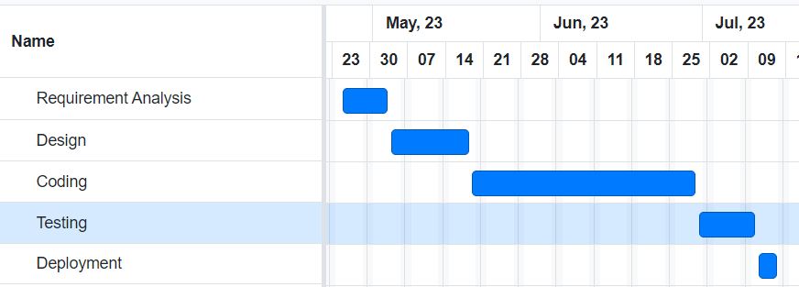

Figure 4: Project Task

## 9.2 Time Schedule

|  |  |  |  |
| --- | --- | --- | --- |
| Time Period | Start | Finish | Duration |
| Requirement Analysis | 25/04/2023 | 04/05/2023 | 11 |
| Design | 05/05/2023 | 20/05/2023 | 15 |
| Coding | 21/05/2023 | 30/06/2023 | 39 |
| Testing | 01/07/2023 | 11/07/2023 | 10 |
| Documentation | 23/07/2023 | 28/07/2023 | 5 |
| Total |  |  | 80 |

Table 4: Time Schedule

# Bibliography/References

1. “Software Engineering-The Incremental Model” [Online] URL : [https://www.researchgate.net/figure/ncremental-ModelAdapted-From-Google-Images-211-Fringe-benefit-of-Incremental-Model_fig2_301513304](https://www.researchgate.net/figure/ncremental-ModelAdapted-From-Google-Images-211-Fringe-benefit-of-Incremental-Model_fig2_301513304?fbclid=IwAR1AXTZCrx_EHTQEm5tR-c1CZWcolcyQ7wKrQiFuwMZSeE1NjspHTyYRgFM)
2. “Task and time schedule” [Online] URL: <https://www.tutorialspoint.com/software_engineering/software_project_management.html>
3. “Demand forecasting model for time-series pharmaceutical data using shallow and deep neural network model” [Online] URL: <https://link.springer.com/article/10.1007/s00521-022-07889-9>
4. “ChatGPT for documentation” [Online] URL: https://openai.com/blog/chatgpt
5. “NepMeds for literature review” [Online] URL: https://www.nepmeds.com.np